Lab 06

|  |
| --- |
| **Exercise:** |

Task 01

Fetch the reviews from the Amazon website for the following categories

* Home entertainment
* Home office furniture
* Fitness equipment and apparel

Task 02

Store the fetched Data in CSV file. Once the reviews are fetched pre-process the fetched data.

Task 03

Apply snetiment analysis over the data. Annotate each data with repsective sentimet.

Task 04

Display the sentiment count in bar graph against respective sentiment of each category.

Solution:  
  
Amazon couldn’t be scrapped Without API access:  
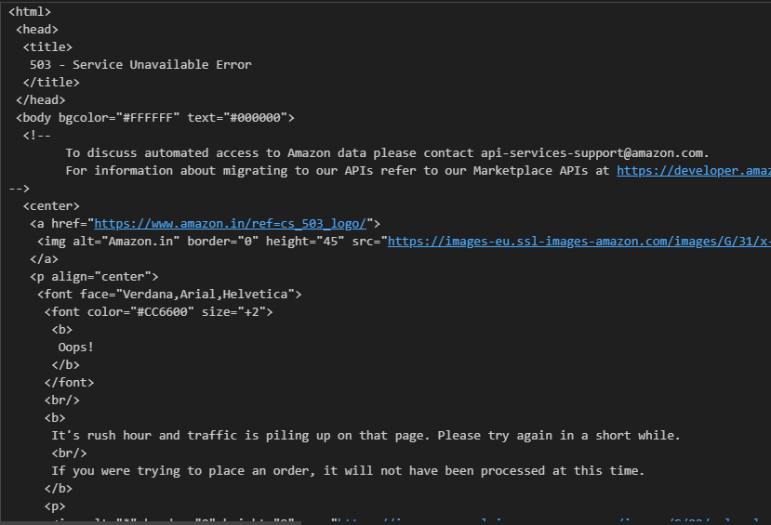

Scrapping Ebay Instead (as discussed Before):

**CODE FILE ATTACHED**